Note:

In the second question

#The parts of Time Series was inspired by TaoTaoSun and Li Yuan

#I learned the code from Li

#This part,I haven't grasp it.Sry,but after the guide from Li Yuan,I can analyze some the question like time series and predication.

#1.1 scatter plot

Some data analysis is done by using scatter plot.

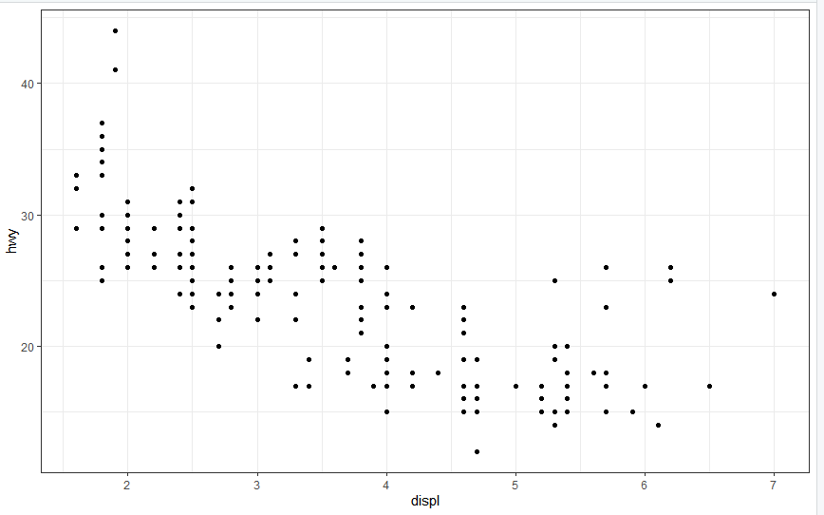

#1.2 Histogram

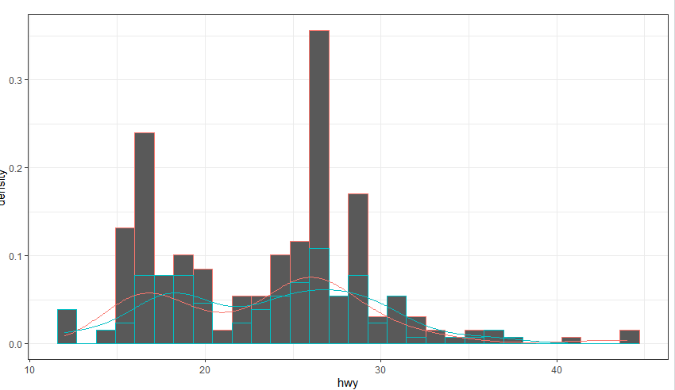

#1.3 box plot

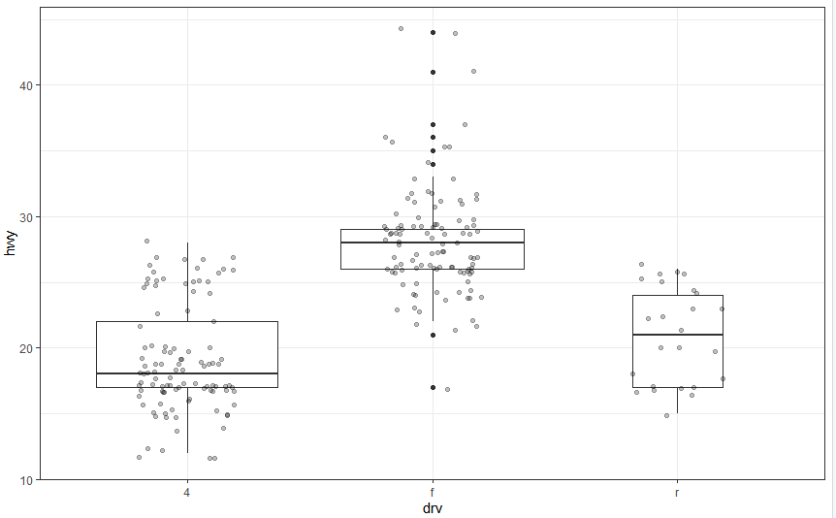

And constantly improve. Sublimation and improvement

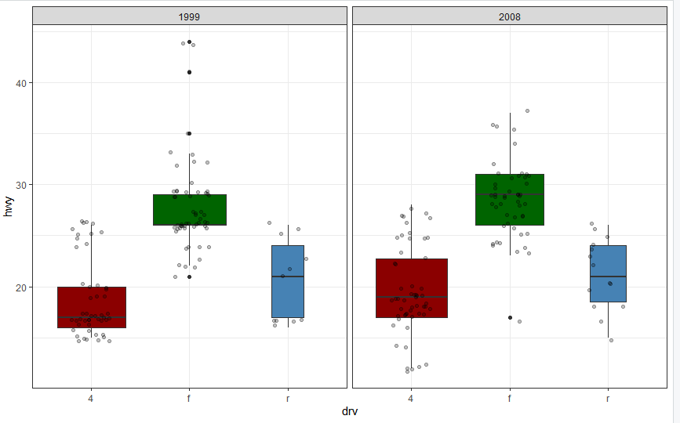

Then, I put it together and show it.

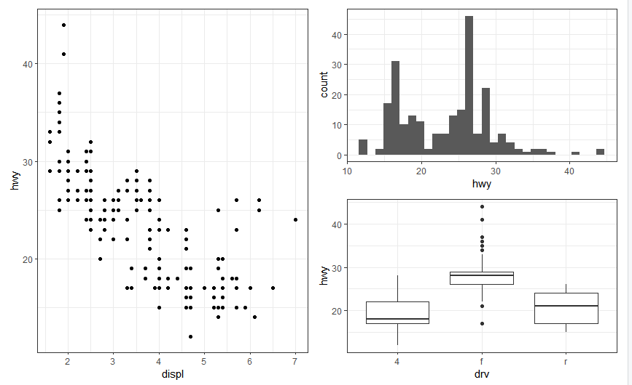

#1.4 Time series

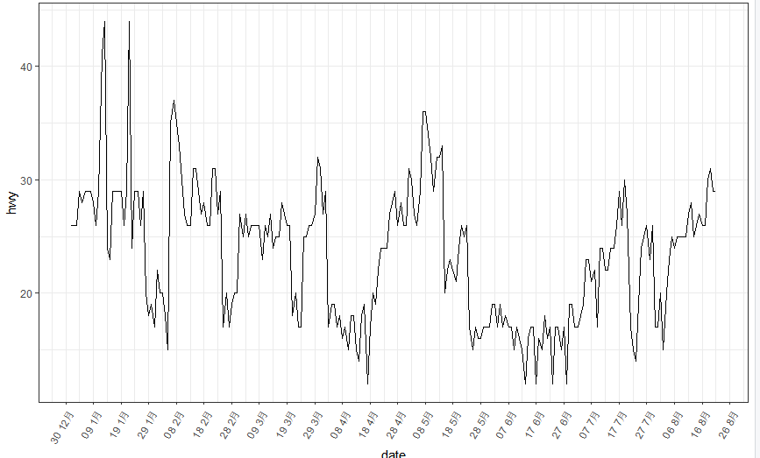

#1.5 image plot

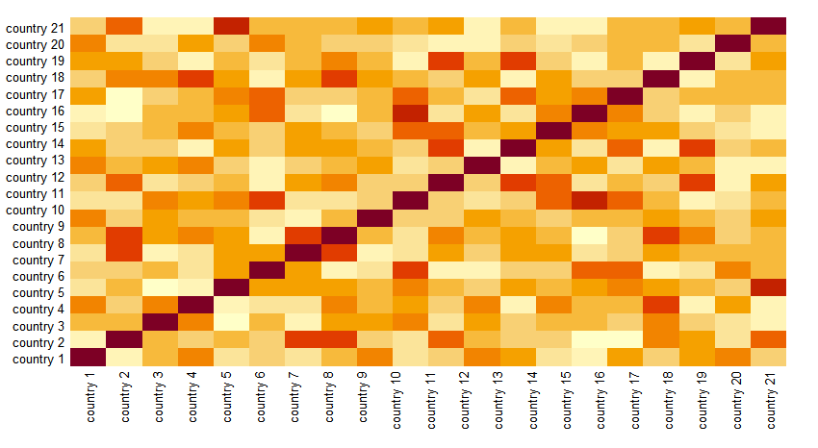

#2.1

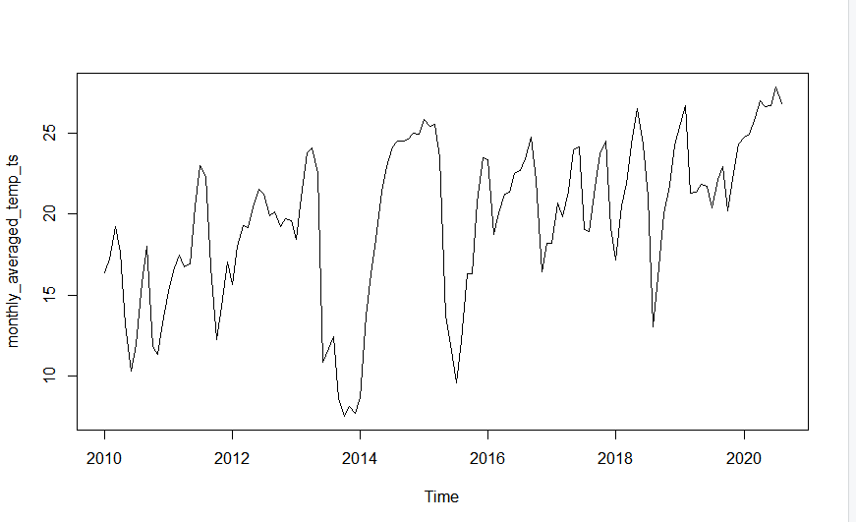

#2.2

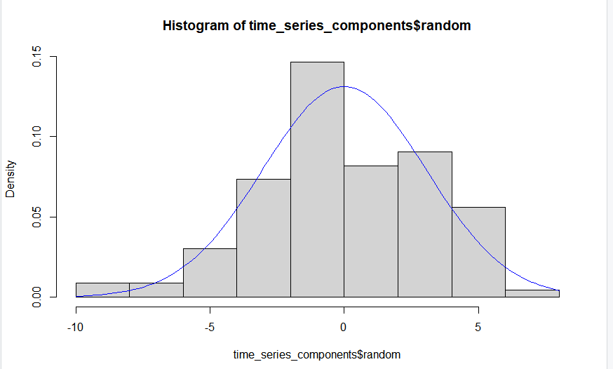

#2.3

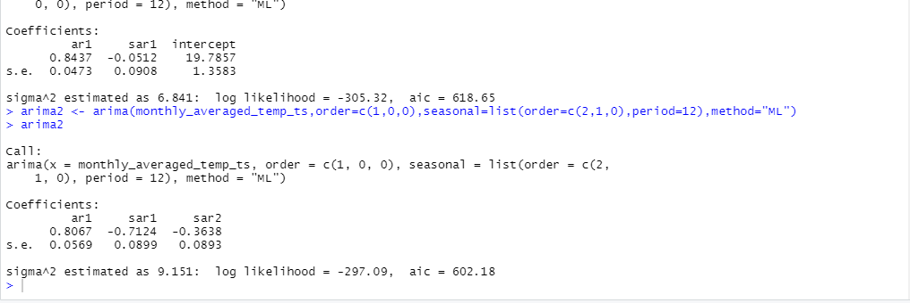

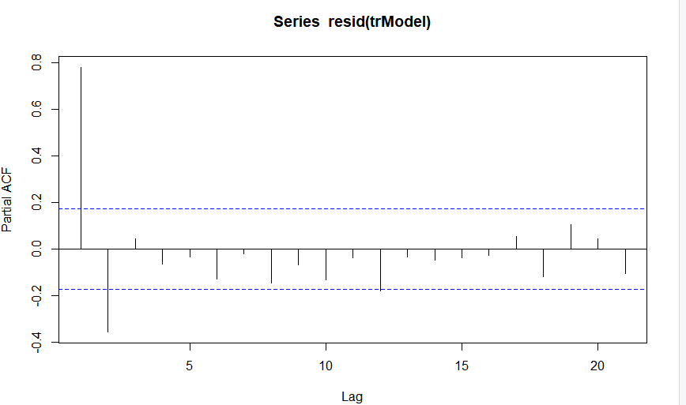

#2.4

